Executive Summary
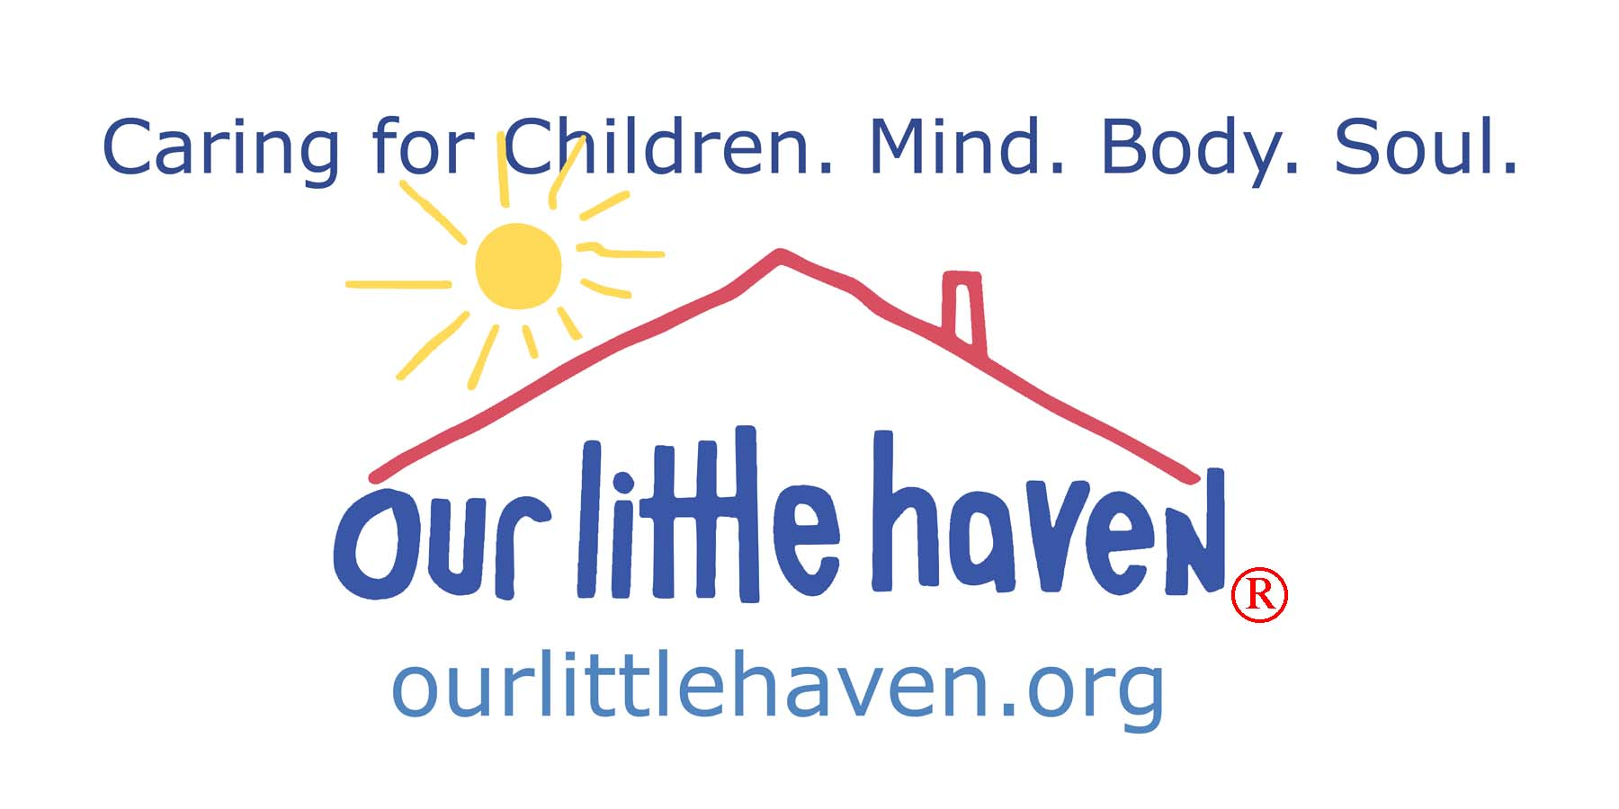

Governance of our little haven

In early 2012, in preparation of the organization entering her 20th year of service, several members of the Board of Directors initiated a process of reviewing, critiquing, and updating governance issues. The exercise resulted in a report with suggestions to the Executive Committee of Our Little Haven. The Executive Committee, charged with the responsibility of visiting the governance issues, initiated a similar process using the report as the basis for the conversation. Meeting regularly for several months focused on governance, legal and accounting issues, the Executive Committee concurred with much of the initial report and currently offer and suggest several updates and changes to better reflect how Our Little Haven is governed.

The Executive Committee of the Board of Directors of Our Little Haven recommends:
- That the advisory body of Our Little Haven is re-named the “Board of Trustees” (replacing the “Board of Directors and Regents”) and all members of the advisory body be identified as “Trustees” (see below for “job description” and expectations.)
- That the Trustees’ terms of office are changed to two year terms (changed from 3 year terms) but continue with no restriction of the number of consecutive terms.
- That the governing body of Our Little Haven is identified as the “Executive Board of Directors” (replacing the Executive Committee) with terms of two years and a maximum of three consecutive terms (unless otherwise determined by the Executive Board) and members of the governing body be identified as “Directors” (see below for “job description” and expectations.)
- That the Executive Board of Directors be limited to 9 voting members; that the members have effectively participated as a Trustee prior to their Executive Board service; and that the Executive Director and the Director of Finance and Operations be non-voting members of the Executive Board of Directors.
- That the By-Laws and Articles of the organization be updated and changed to better reflect the volunteer services offered by the Leadership of Our Little Haven.

Board of Trustees. Acts as an Advisory Board made up of individuals who are interested in supporting the organization, the clients, and the Mission. This Board would combine the current Board of Directors and Board of Regents. This group is elected to two year terms and may serve three consecutive terms. The members of the Board of Trustees are expected to:

Attend semi-annual Board meetings

Attend OLH fundraising events

Contribute financially and be responsible for inviting other contributors

Serve on a Committee if requested

Promote OLH’s public standing and encourage community support.

Executive Board of Directors. Acts as OLH’s governing body. This body is limited to 9 voting members, and two non-voting members, the Executive Director and the Director of Finance and Operations. The Directors serve two year terms which would be staggered to assure continuity. The Chairperson of the Executive Board of Directors would also be the Chairperson of the Board of Trustees. This body would select a Member who would be the Secretary of the Directors and note taker of the Executive Board of Directors. The Executive Board of Directors is responsible for and expected to:

(1) Prepare for and attend quarterly meetings of the Executive Board and 2 Board of Trustee’s meetings

Appoint and assess performance of the Board of Trustees, Executive Board of Directors, Officers, and Committees

Review and approve the financial statements, financial controls and budget of OLH and provide proper financial oversight

Review and act upon the recommendations of the Committees

Determine, review and act upon any changes to OLH’s Mission or Purpose

Designate any new Committees and appoint the members of any such Committee.

Participate, as required, in the various accreditation processes that OLH undertakes

Select and evaluate the Executive Director, the DFO and any other Officer positions

Participate in strategic planning

Monitor and strengthen program services

Assist with legal and ethical integrity

Promote OLH’s public standing and encourage community support.

Officers of the Corporation Committees of the Executive Board

(1) Executive Director (1) Audit/Compensation

(2) Director of Finances/Treasurer (2) Investment

(3) Therapeutic Director

(4) Corporate Secretary

Committees of the Board of Trustees

(1) Golf Tournament (5) Dinner Dance

(2) Card Party (6) Fashion Show

(3) Funding Development (7) Courage Fund Development

(4) Strategic Planning (8) Haven Club

